**Governor Stirling Senior High School**

**2019 Year 12 Physics**

**Task 10: Test 5 – Relativity, Particle Physics and Cosmology**

RELATIVITY, PARTICLE PHYSICS AND COSMOLOGY

**ANSWERS /55**

**Question 1 (10 marks)**

A linear accelerator is used to accelerate particles through a series of tubes (drift tubes). There is a potential difference between each pair of tubes that accelerates the ions.

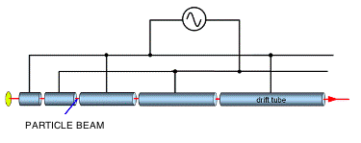

The ends of two consecutive tubes in a linear accelerator have a potential difference of   
10 000 V across them. A beam of electrons with a speed of 1.8 x 104 m s-1 travels across a   
3.0 cm gap between the two tubes. Find the following.

1. The electric field strength between the tubes. (2 marks)  
     
   ***E=V/d = 10,000/0.03   
   = 3.33 x 105 V m-1 (N C-1)***
2. The work done on each electron by the electric field between the gaps. (2 marks)  
     
   ***W = qV***

***= 10,000 x 1.6x10-19*✓**

***= 1.6 x 10-15J***

1. The speed of the electrons when they enter the second tube. (4 marks)  
     
     
   ***½ mv2 = W + initial KE*  (1)**

***= 1.6 x 10-15 + ½ x 9.1 x 10-31 x (1.8 x 104)2* (2)**

***= 1.6 x 10-15***

***v = 5.93 x 107 m s-1* (1)**

1. Is the final speed of the electrons sufficiently high for the effects of the Theory of Special Relativity to significantly affect their motion? Explain. (2 marks)

***Yes (1)***

***It is approximately 20% the speed of light and therefore relativistic effects will be significant . (1)***

**Question 2 (4 marks)**

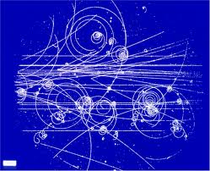High-energy particle physicists have discovered a new sub-atomic particle that is produced as a by-product of extremely energetic collisions between other particles in their particle accelerator. The new sub-atomic particle moves at 99% of the speed of light when produced; it has a mass of 4.70 x 10-25 kg and decays with an average lifetime of 22 μs. Would these new sub-atomic particles have the same mass and average lifetime if they could be produced at rest in the laboratory? Briefly explain your answer.

**The new sub-atomic particles would NOT have the same mass and average lifetime if they were produced at rest in the laboratory (1)**

**➔the mass and average lifetime of the new sub-atomic particles were measured when they were moving at very high speed relative to the observer (1)**

**➔both their mass and average lifetime would have been dilated due to this very high relative speed (1)**

**➔ if they were produced at rest in the laboratory, both their mass and average lifetime would have been smaller (1) (they would have been the *proper* values)**

**Question 3 (7 marks)**

Edwin Hubble established that distant galaxies are moving away from us with a velocity proportional to their distance; this relationship is written as v = H0 d where the constant of proportionality H0, known as Hubble’s constant, indicates the rate of expansion of the universe. A galaxy cluster that is 400 million light years distant is measured to be moving away from us at a speed of 8.7 x 106 m/s.

(a) Use this data about the galaxy cluster to estimate a value for Hubble’s constant in units of

*km/s* per *mega light*-*year.* (2 marks)

**Ho = v/d = 8.7 x 103 kms-1 / 400 Mly (2)**

**= 21.7 kms-1Mly-1**

(b) Use your value of Hubble’s constant to estimate the age of the universe, expressing your answer to the nearest billion years. (3 marks)

**L = 8.7 x 106 x 10-3 (365.25 x 24 x 60 x 60) kmyr-1 (1)**

**400 x 106 x 3 x108  x 10-3 (365.25 x 24 x 60 x 60) km**

**= 8.7/ 400 x 3 x108 = 7.23 x 10-11 yr-1 (1)**

**Age = 1/Ho = 1/7.23 x 10-11 yr = 1.38 x 1010 years**

**Which is approx. 14 billion years (1)**

(c) Distant galaxies moving away from us is evidence for the “Big Bang” theory. State the two other observations which also provide evidence for this? (2 marks)

**The predicted abundance of hydrogen and helium produced shortly after the Big Bang agree with observations.**

**The discovery of cosmic microwave background radiation matched predictions from the Big Bang theory**

**Question 4 (4 marks)**

The spectrum of light from most stars contains lines corresponding to helium gas.

Figure (*a*) shows the helium spectrum from the Sun.

Figure (*b*) shows the helium spectrum from a distant star.

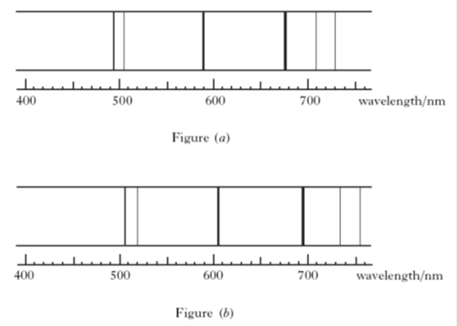

Given v = (Δλ/λo) c, where λO is the wavelength of a spectral line in the sun and Δλ is the change in wavelength of this spectral line in the distant star:

Estimate the recessional velocity of the galaxy from this spectral data.

**Examples:**

**(508-492) x 10-9  x 3 x 108 = 9.9 x 106 ms-1**

**492 x10-9**

**(608-590) x 10-9  x 3 x 108 = 9.2 x 106 ms-1**

**590 x10-9**

**(695-675) x 10-9  x 3 x 108 = 8.9 x 106 ms-1**

**675 x10-9**

**1 mark selecting lines and estimating values**

**1 mark calculation**

**1 mark between 8.0 – 10.1 x 106 ms-1**

**1 mark answer to 2 sig figs**

**Question 5 (5 marks)**

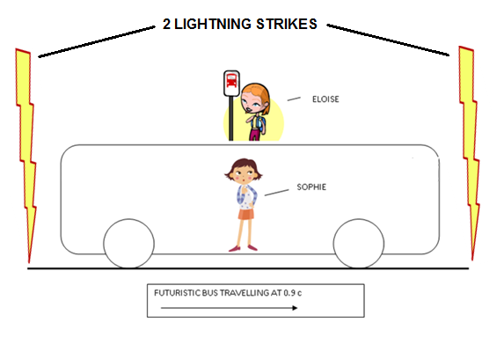Sophie is traveling on a futuristic bus that is travelling to the right at a constant speed of 90% of the speed of light. The bus travels straight past Eloise who was waiting for another bus. At the instant that the centre of the bus passes Eloise, she notices 2 lightning strikes at either end of the bus. Eloise observes that the 2 flashes of light occurred simultaneously (at the same time).

Eloise thinks that Sophie will see the lightning strike closest to the front of the bus first as the bus is “travelling to meet” the light from the front strike. In fact Sophie **does** observe the front strike first, but concludes that the front strike happened before the strike at the back of the bus.

1. Is one girl’s interpretation of the events more correct than the other’s? Explain carefully by making reference to Einstein’s Theory of Special Relativity. (2 marks)

Both interpretations are equally correct. No reference frame is favoured over

any other in determining the sequence of events.

1. How does Sophie explain that the two flashes of light reach Eloise simultaneously? (3 marks)

From Sophie's point of view, the front strike was first, then the back strike, which explains why Eloise (travelling to the left) sees them as simultaneous.

i.e Sophie infers that Eloise was travelling to the left to meet the light from later strike, thus seeing it at the same time as the earlier strike.

**Question 6 ( 7 marks)**

An alien observer on the planet Vulcan is witnessing a nearby battle between the United Federation of Planets and the Borg. The alien sees the Starship Enterprise chasing a Borg Cube.

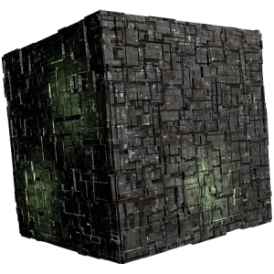

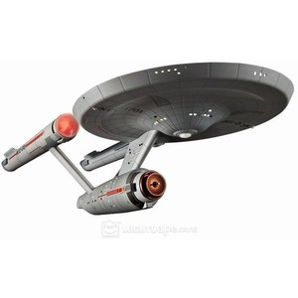

He measures the Enterprise to be travelling at 0.90c and the Borg Cube to be travelling at 0.70c. Calculate the velocity of the Enterprise relative to the Borg cube.

**u’ = u - v**

**1 - uv/c2**

**= 0.9c – 0.7c (2)**

1. **(0.9c . 0.7c)/c2**

**= 0.2c / 0.37**

**= 0.54c (towards the Cube) (2) ans**

(4 marks)

The Borg ship fires a phasor beam (an extremely high frequency beam of light) at the Enterprise.

Determine how fast the crew of the Enterprise will see the beam travelling towards them

* + - * 1. As predicted by Newton:

(2 marks)

**0.9 + 1.0 – (-0.7) = 2.6c**

* + - * 1. As predicted by Einstein:

**C** (1 mark)

**Question 7 (8 marks)**

In the science fiction series *Willo Trek*, Captain Taylor decides to test his brand new starship with a quick trip from Earth to Pluto and back to Earth.



During the trip, the starship travelled at a speed of 0.98*c*

(*c* = speed of light). Captain Taylor’s identical twin brother, Doc Taylor, who remained on Earth, measured the total travel time to be 12.50 hours.

1. As seen by Doc Taylor on Earth, calculate the distance from Earth to Pluto in kilometers. (2 marks)

**s = 0.98 x 3 x 108 x 12.5 x 60 x 60 (1)**

**= 1.323 x1013 m**

**= 1.32 x1010 km (1)**

**Distance (1 way) = 6.6 x 109 km**

1. As seen by Captain Taylor, calculate how far his journey would have been.

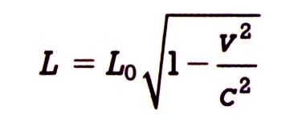

***L* = 1.32 x1010 km ( 1- (0.98c)2 / c2)1/2 (1)**

**= 2.63 x109 km (1.315 x109 km ok) (1)** (2 marks)

1. What is the journey time as experienced by Captain Taylor?

1 `

**t = L/v = 2.63 x 109 km / 0.98c = 2.49 hours**

Can use: **(2 marks)**

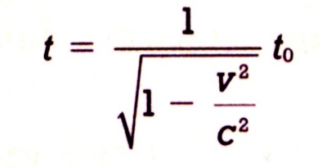

**12.5 = to = 2.49 hours**

**(1 - (0.98c)2/c2)1/2**

1. If it was possible for Doc Taylor to see the clock on the spaceship, how much time would he observe to pass on the spaceship during the trip?

**Answer: Doc would see same time passing on the ship: 2.49 hours (1 mark)**

(e)If it was possible for Captain Taylor to see Doc Taylor’s clock on the Earth, how much time would he observe to pass on the Earth during the trip?

(1 mark)

**2.49 hours**

**Question 8 (10 marks)**

The standard model of particle physics proposes that heavy sub-atomic particles (hadrons), such as the proton or neutron, are actually composite particles made of different combinations of more fundamental particles known as quarks. There are 6 quarks whose properties are listed below.

|  |  |  |  |  |  |  |  |
| --- | --- | --- | --- | --- | --- | --- | --- |
| **NAME** | **SYMBOL** | **Charge (Q)** | **Baryon Number (B)** | **Strangeness (S)** | **Charm**  **(c)** | **Bottomness (b)** | **Topness**  **(t)** |
| *Up* | u | e |  | 0 | 0 | 0 | 0 |
| *Down* | d | e |  | 0 | 0 | 0 | 0 |
| *Strange* | s | e |  | -1 | 0 | 0 | 0 |
| *Charmed* | c | e |  | 0 | +1 | 0 | 0 |
| *Bottom* | b | e |  | 0 | 0 | -1 | 0 |
| *Top* | t | e |  | 0 | 0 | 0 | +1 |

(a) State the quark composition of the following hadrons: (3 marks)

(i) the Lamda-zero Ao , baryon with Q = 0, B = +1, and S = -1 and c = b = t = 0

uds

(ii) the charmed Xi (Ξ+c) baryon, with Q = +1, B = +1, S = -1, c = +1 and b = t = 0

usc

(iii) the D-zero meson, with Q = 0, B = 0, c = +1 and s = b = t = 0

uc

(b) When a K– meson collides with a proton, the following reaction can take place.

$$K^{-}+p → K^{0}+K^{+}+X$$

X is a particle whose quark structure is to be determined.

The quark structure of the mesons in the reaction is given below.

|  |  |
| --- | --- |
| **particle** | **quark structure** |
| K– |  |
| K+ |  |
| K0 |  |

Is the original K– particle a hadron, a lepton or an exchange particle? Explain.

(2 marks)

**Is a hadron (1)**

**Because it is made up of quarks (1)**

Assuming this reaction occurs, determine the baryon number of X, and hence deduce the quark structure of X. Note: in this reaction the number and types of quarks are conserved.

**Baryon No = 1**

**sss**

(2 marks)

In order to answer Part (c) below, you will need to refer to the following table:

Table of Leptons:

|  |  |  |  |  |  |
| --- | --- | --- | --- | --- | --- |
| Lepton | Symbol | Charge | Le Number | Lμ number | Lτ number |
| Electron | e- | -1 | +1 | 0 | 0 |
| Electron neutrino | υe | 0 | +1 | 0 | 0 |
| Muon | μ- | -1 | 0 | +1 | 0 |
| Muon neutrino | υμ | 0 | 0 | +1 | 0 |
| Tau | τ- | -1 | 0 | 0 | +1 |
| tau neutrino | υτ | 0 | 0 | 0 | +1 |

(c) Consider the reaction as shown below.

μ- τ- + υμ + υτ

Determine whether the above reaction can take place. Justify your answer with appropriate workings, noting Baryon Number, lepton numbers and charge.

(3 marks)

**Baryon number: 0 = 0 (1/2)**

**Tau lepton number: 0 = 1 + 0 – 1 (1)**

**Muon lepton number: 1 = 0 + 1 + 0 (1)**

**Charge: -1 = 0 + 0 -1 (1/2)**

**Hence reaction can take place**.

**END OF TEST**